Part 1 — Hands-On Practice (Approx. 70 min)
A. Initialize and Configure (10 min)
- Create a folder named day1_day2_practice.
- Initialize Git and check for the .git folder.
- Configure username + email (locally).
git init
git config user.name "Your Name"
git config user.email "your@email.com"
git config --list --local
📝 Deliverable → Screenshot showing git init and git config output.
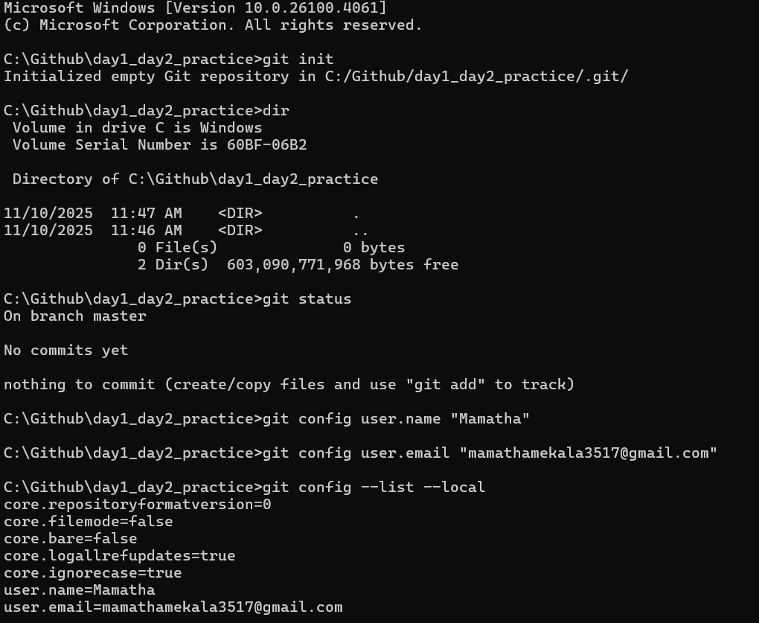
. File Lifecycle (25 min)
- Create three files:
intro.txt setup.txt notes.txt
- Add some text to each.
- Stage only intro.txt and setup.txt.
git add intro.txt setup.txt
git status
- Edit intro.txt again without re-adding.
- Compare results of:
git diff
git diff --staged
- Commit staged files:
git commit -m "First commit - intro and setup"
📝 Deliverable → In 2–3 sentences, explain why the second edit to intro.txt didn’t go into the commit.
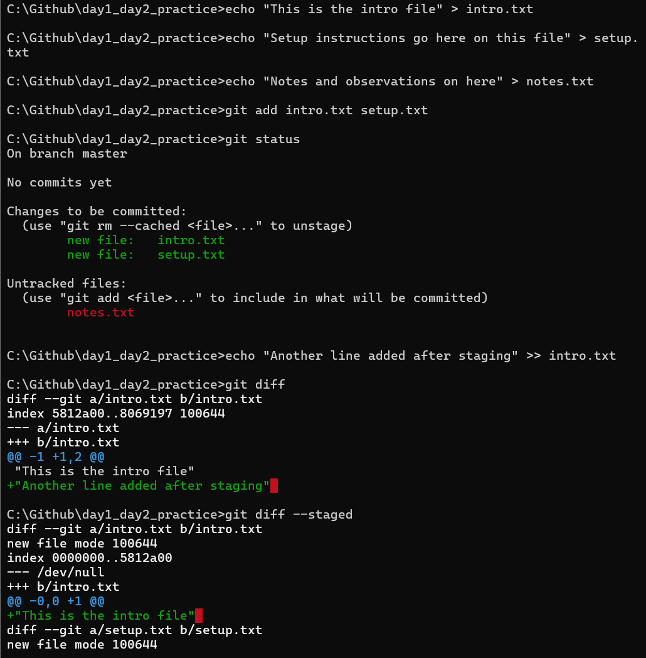
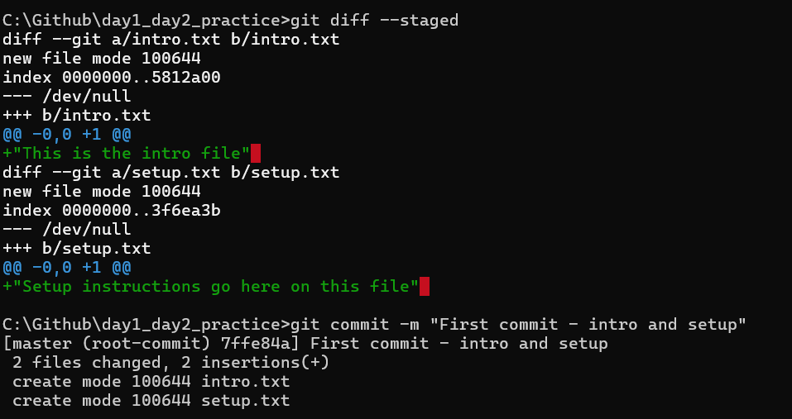
C. Inspect Internals (25 min)
Run these and note what each displays:
ls -a

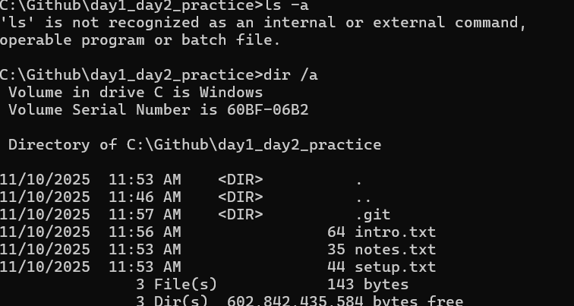
git log –oneline

git show HEAD
git cat-file -p HEAD
git cat-file -p HEAD^{tree}
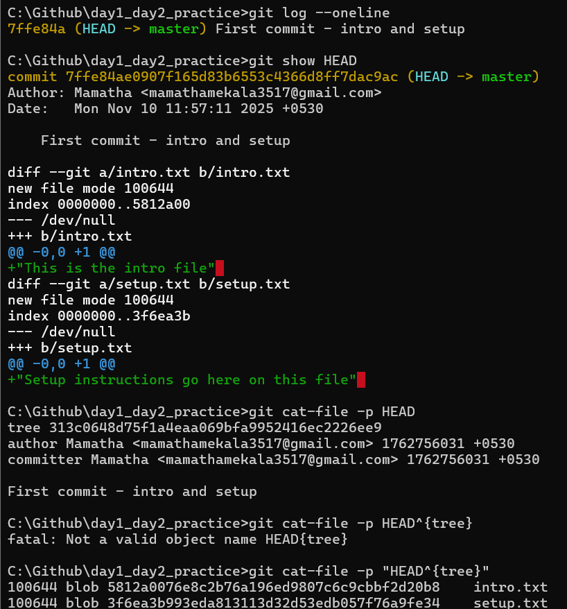
Then find one blob id and open it:
git hash-object intro.txt
git cat-file -p <that_hash>
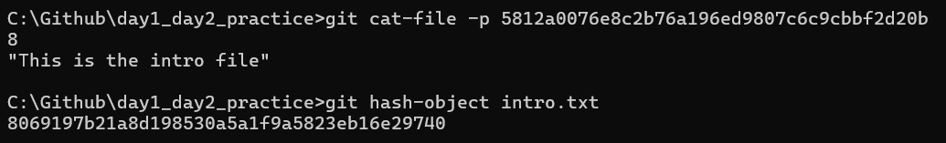
📝 Deliverable → Answer in 3–4 lines: what are blob, tree, and commit object?

  - A blob object stores the actual file contents (just raw data, no filenames or structure).
  - A tree object represents a directory. it maps filenames to blob IDs and other trees, giving structure to the project snapshot.
  - A commit object ties everything together . it points to a tree means the snapshot, records metadata like author, date, message, and links to parent commits to form the history.

Part 2 — Conceptual Quiz (Approx. 40 min)
Answer briefly (3–4 sentences each, simple English):
- What happens inside Git when you run git add file.txt?
- Git takes the current version of file.txt and saves it into the staging area. It creates a blob object with the files contents and records its hash in the index. This means the file is now marked to be included in the next commit.
- Why do we say a commit is a snapshot, not a diff?
- A commit stores the entire state of the project at that moment , not just the changes . git points to tree objects that represents all files ,so we can always reconstruct the full project.
- Diffs are calculated later when comparing commits, but the commit itself is snapshot.
- What is stored inside the .git folder?
- The .git folder contains all of git internal data like commits, trees ,blobs, branches, tags and configuration. its basically the database of my repository.
- What does HEAD point to, and how is it updated?
- HEAD is a pointer to your current branch reference like main or directly to a commit. When you checkout or switch branches , HEAD updates to point to that branch. When you commit , HEAD moves forward to the new commit.
- What’s the difference between the Working Directory and the Staging Area?
- the working directory is where you edit files on your computer. The staging area is where you prepare selected changes for the next commit. Only staged changes go into the commit, unstaged edits stay in the working directory.
- What happens if you change a file after staging it?
  - The staged version stays the same until you run git add again. The new edits are only in the working directory and won’t be committed. this means the commit will include the old staged snapshot, not the latest changes.

- Why doesn’t Git store whole files for every commit?
  - Git stores blobs only once and reuses them if the file has not changed. This saves space and makes commits efficient. Instead of duplicating files , git links commits to existing objects and only adds new blobs when content changes.

- What is version control, and how does Git make it easier?
  - Version control is a system that tracks changes to files over time. Git makes it easier by letting you save snapshots , roll back to earlier versions and work on branches without losing history , it also supports collaboration by syncing with remote repositories.

- What are tracked vs untracked files?
  - Tracked files are already known to git and will be included in commits.
  - UnTracked files are new files in your working directory that git hasn’t been told to manage yet . so we can start tracking them with git add.
- Write the complete flow of commands from creating a repo to committing your first file.
git init
echo “Hello Git “ >file.txt
git add file.txt
git commit -m “first commit”

